PROTOCOL
2nd World Olympics, 2nd World Championship, 2nd Open South America Championship, 2nd Open Ecuador Championship, International Tournament in honour of Simeon Bolivar on Kettlebell Triathlon under the extreme conditions of highland on Chimborazo Volcano, the world’s highest mountain (if measured from the Earth center up to the peak)
Height 5,010 m
South America, Ecuador, Chimborazo Volcano 27 February 2014
Name | Country | Date of Birth | Weight | Weight class | Result | Place | Record
MEN
Kettlebell jerk (16 kg) with one-time interception, Time-limit 1 min.
Weight class under 70 kg.

1. Alexander Ezhov | Russia | 1982 | 69,6 | 70 | 63 | 1 | OR, WR
2. Haime Medrano | Ecuador | 1989 | 66,1 | 70 | 59 | 2 | –
3. Luis Reyes | Ecuador | 1968 | 65,2 | 70 | 38 | 3 | –
Weight class under 75 kg
1. Vladimir Katashuk | Belarus | 1956 | 73,2 | 75 | 49 | 1 | OR, WR
2. Alex Lomas | Ecuador | 1978 | 71,9 | 75 | 47 | 2 | –
3. Raymon Masalles | Chile | 1987 | 74,5 | 75 | 39 | 3 | –
Weight class under 90 kg
1. Victor Sayko | Kazakhstan | 1955 | 88,8 | 90 | 59 | 1 | OR, WR
2. Jacques Fisher | Canada | 1985 | 88,8 | 90 | 37 | 2 | –
3. Kwinta Pedro | Surinam | 1994 | 85,5 | 90 | 35 | 3 | –
Weight class under 95 kg
1. Andrey Lisitsyn | Russia | 1994 | 91,1 | 95 | 75 | 1 | OR, WR
2. Miguel Ignasio | Peru | 1979 | 93,7 | 95 | 41 | 2 | –
3. Emanuel Gugo | Colombia | 1992 | 94,5 | 95 | 40 | 3 | –
Long cycle (16 kg) with one-time interception 1 min.
Weight class under 85 kg.

1. Nickolay Levchenko | Ukraine | 1949 | 83,4 | 85 | 25 | 1 | OR, WR
2. Samuel Peress | Colombia | 1991 | 84,7 | 85 | 21 | 2 | –
3. Augusto Chavez | Venezuela | 1987 | 84,9 | 85 | 19 | 3 | –
Weight class under 110 kg
1. Anatoly Ezhov | Belarus | 1946 | 107,3 | 110 | 37 | 1 | OR, WR
2. Andres Fernandez | Uruguay | 1977 | 106,3 | 110 | 22 | 2 | –
3. Sergi Alkalle | Paraguay | 1993 | 108,9 | 110 | 21 | 3 | –
Weight class + 110 kg
1. Vladimir Sadakov | Russia | 1967 | 112,2 | +110 kg | 25 | 1 | OR, WR
2. Serafim Gonzales | Venezuela | 1991 | 111,0 | +110 kg | 17 | 2 | –
3. Manuel Rojiero | Chile | 1987 | 115,3 | +110 kg | 15 | 3 | –
Kettlebell snatch (16 kg) with one-time interception
Weight class under 55 kg
1. Alexander Iofinov | Belarus | 1940 | 54.9 | 55 | 21 | 1 | OR, WR
2. Juanito Veres | Peru | 1993 | 54.5 | 55 | 19 | 2 | –
3. Diego Dorado | Argentina | 1989 | 54.6 | 55 | 18 | 3 | –
Weight class under 60 kg
1. Oleg Lisitsyn | Russia | 1953 | 59,5 | 60 | 31 | 1 | OR, WR
2. Jack Puri | Panama | 1995 | 59,7 | 60 | 21 | 2 | –
3. Luis Reyes | Ecuador | 1985 | 59,8 | 60 | 20 | 3 | –
Weight class under 65 kg
1. Valery Veretennikov | Russia | 1952 | 64,7 | 65 | 41 | 1 | OR, WR
2. Mar Botizha | Bolivia | 1991 | 63,5 | 65 | 19 | 2 | –
3. Fernando Alenso | Colombia | 1989 | 64,1 | 65 | 18 | 3 | –
Weight class under 80 kg
1. Nickolay Sungurov | Russia | 1957 | 76,1 | 80 | 27 | 1 | OR, WR
2. Victor Revilla | Uruguay | 1994 | 78,9 | 80 | 23 | 2 | –
3. Adolfo De Bosta | Paraguay | 1969 | 79,1 | 80 | 21 | 3 | –
Weight class under 85 kg
1. Nickolay Levchenko | Ukraine | 1949 | 83,4 | 85 | 39 | 1 | OR, WR
2. Urbino Morallez | Cuba | 1991 | 84,9 | 85 | 23 | 2 | –
3. Mouricio Sanchez | Spain | 1985 | 82,5 | 85 | 21 | 3 | –
WOMEN
Kettlebell jerk (12 kg) with one-time interception. Time-limit 1 min.
Weight class under 60 kg
1. Marina Maslova | Belarus-Russia | 1978 | 58,6 | 60 | 45 | 1 | OR, WR
2. Tereza Esmanyolez | Venezuela | 1988 | 59,9 | 60 | 25 | 2 | –
3. Marta Perez | Colombia | 1985 | 59,9 | 60 | 21 | 3 | –
Note: OR – Olympic record; WR – World record
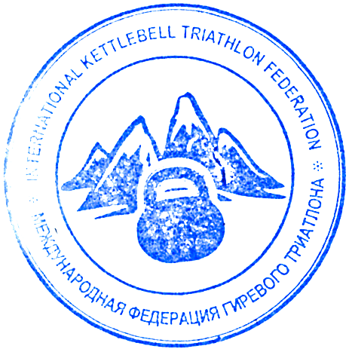
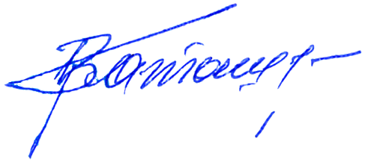
The overall winner in long cycle (16 kg) in 1 minute with the score 37 lifts is Anatoly Ezhov (Belarus)
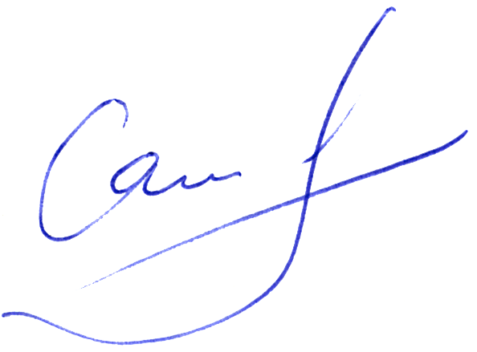
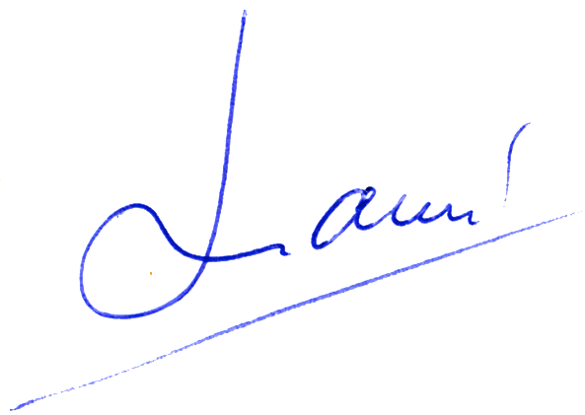
Chief referee Vladimir Katashuk (Belarus)
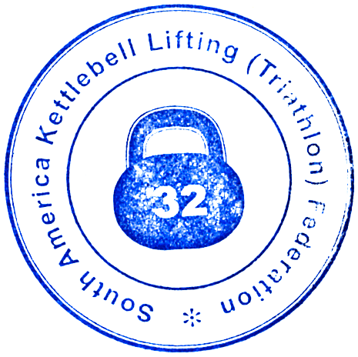
Chief secretary Victor Sayko (Kazakhastan)
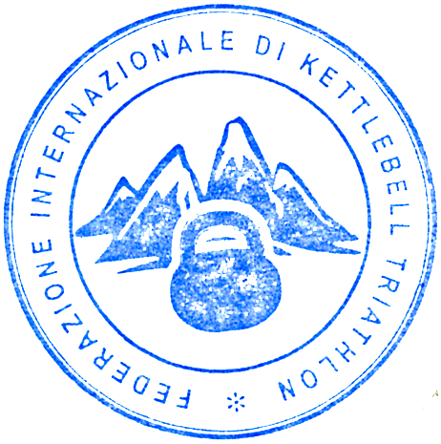
Chief platform referee Alex Lomas (Ecuador)

